Southover CE Primary School
Everyone at Southover
achieves their potential,
is valued for who they are
and knows they belong

Telephone (01273) 473015
Headteacher: Noel Fadden
Live, Love, Learn!
www.southoverceprimary.co.uk
Email: office@southover.e-sussex.sch.uk
At Southover Church of England Primary school:
We all work together —children, parents, staff, Trinity Church and the community.
We inspire each other to learn through a vibrant curriculum, set within a safe environment that meets the needs of all children.
We gain strength from the love of God and our love for one another; we feel we belong to Trinity Church.
We value: Trust, Compassion, Friendship, Hope, Thankfulness and Fellowship.
We have a healthy mind, body and spirit to allow us to ‘Live, Love, Learn’.

Newsletter December 2024

Dear Parents, Carers and the Community of Southover,

As term closes we look back on a very busy and successful autumn at Southover. We have been focusing on our key value of Thankfulness in our assemblies this term and I am very thankful for everyone who has given their time and talents to enrich the children’s experiences. We have had Christmas shows for all years and the time and efforts of staff to enable these to be so good is much appreciated by myself, and, judging by the response of the audiences, by the parents and carers. A lot of extra time and effort has been put in to enable the children to perform so well.

Sadly, we say goodbye to Lucy Powell who is moving on to a new role at Priory School but will be sadly missed for her positivity and energy as TA in KS2 and at lunchtime as an MDSA. Good luck to Oliver Platt who has been working in the office on finance and is also leaving to take on a full-time role. We wish them both well and thank them for their contributions to the school.

Southover staff have had recent training in looking out for and dealing with anaphylaxis reactions. Please remember we are a nut-free school so no nut products e.g. Nutella, humous with tahini or almond croissants on site.

Continuously Developing the School – part of our School Development Plan We have a healthy mind, body and spirit to allow us to ‘Live, Love, Learn’.
Our newly formed Diversity group met to share ideas to improve what we offer in terms of increasing awareness of diversity and ensuring everyone feels valued and knows they belong. The meeting had some great ideas and a team willing to make a difference. If you speak a language other than English and would be willing to help translate a conversation in that language then please let us know. We know there are many languages spoken and sometimes others can benefit from support with trying to explain things clearly. Please email the office and we will create a language resource bank.
Enrichment - We inspire each other to learn through a vibrant curriculum

Well done to the Friends (PTA) for the wonderful Christmas Fair. Santa’s Grotto was very busy and the gym was heaving with families enjoying the wide variety of stalls. Children were happily making, buying or playing as we raised money for the school. The choir sang beautifully outside and the raffle had thirteen lucky winners. Whilst the Fair was a busy and successful 90 minutes, the planning and preparation had been going on for months – thank you to all involved.

Music

The Choir have been in excellent, festive voice and gave a strong, joyful performance to raise everyone's spirits at the Southover Christmas Fair. The highlight of our singing this term has been performing on the stage at Glyndebourne as part of the One Voice Festival organised by Create Music. They were joined on stage by the Glyndebourne Chorus and Orchestra and created some real Christmas magic that will be long remembered and treasured by the Choir themselves as well as their parents and teachers. Many thanks go to Mrs Fenton and Ms. Hayward-Tapp who teach the choir on Mondays after school; they teach them very well!

Sport We have a healthy mind, body and spirit
Netball
Ms Miller says: “Proud is an understatement. The netballers have represented the school in multiple matches with determination, skill and respect. The commitment to the weekly training sessions has been impressive and it is a pleasure working with them to develop their skills. This paid off as last week we drew our last match and it is the first time we haven't conceded a goal. This was a huge result and the children were rightly thrilled by this achievement.” Thank you to Ms Miller for running the club at 8am on a Friday!


Chess
We have a vibrant chess club and had a chess team play in a match against Lewes Old Grammar School last week. Holly, Joseph, Bertie, Bea, George, Louis, Yaser and Lenny represented the school really well and tested their mental strength and chess skills against children in Y5 to Y7. They played well and the overall scores meant a 9-9 draw. Many thanks to Mr Rogers and the team from LOGS for their hospitality.

Lunchtime Clubs
Would anyone be able to offer an hour a week at lunchtime to run a club? We would love to offer a coding/computing club, an extra chess club, a library session or a table tennis club. Please let me know.
Curriculum Updates - We inspire each other to learn through a vibrant curriculum
Year 5 and 6 have had a jam packed half term filled with exciting learning. In English, children in Year 6 have shown off their skills in action writing by producing chase scenes inspired by the Paddington movie, Tintin and extracts from inspiring children's books.
Year 5 have been working hard on learning the features of instruction writing. They have practised the different features by thinking about how to decorate the perfect Christmas tree or how to make the best Christmas dinner. Now, they are busy getting into character as the Grinch and preparing to write a set of instructions on how to steal Christmas! They are looking forward to writing these up as creative double page spreads, including illustrations of the Grinch (and maybe even Max as a reindeer too!)
In Science, Year 5 and 6 have learnt about how living things are classified and they might be able to impress you with their knowledge of the six kingdoms and the work of Carl Linnaeus. We've experimented with the best conditions to speed up mould growth on bread and have observed the spore production of fungi.
Y5 have had another exciting term! Both classes made some fantastic festive decorations (bobble hats and Christmas puddings) for the Christmas hoops. Nightingale Class have also continued to enjoy their forest school sessions this term, keeping warm by the fire outside in the cold weather.
It's been a busy term for the amazing Year 3 and 4 pupils! They have been mastering gymnastics skills, focusing on dynamic balance techniques and creating impressive sequences that showcase their creativity and control.
They absolutely smashed their Nativity performance, demonstrating all the skills they’ve learned and mastered with incredible flair. Their bravery, dedication, and gorgeous singing made the show truly remarkable, and we couldn't be prouder of their achievement!
Kingfisher have been thoroughly enjoying forest school and have benefitted enormously from the opportunities to engage in outdoor learning. Skylark and Osprey have been exploring pneumatic systems in DT and are excited to be creating their toys and evaluating their designs in in their last week of term. Have a wonderful break and we look forward to starting the New Year with our exciting new topic - The Romans!
We have had an exciting and busy term in Y1/2. The children have been working very hard and the joy of Christmas is definitely here. We have been reading 'Mog at Christmas' and thinking about why the author Judith Kerr has chosen particular vocabulary to reflect the theme of the story. It has been fun travelling the globe in Geography, learning about hot and cold climate zones. This has linked nicely with Science, where the children have been exploring how animals have adapted to their habitat, the different animal groups and differences between wild and domesticated animals. The children have demonstrated excellent singing, dancing and acting skills as they took to the stage to perform the Nativity. We have many budding superstars!
In Reception we went on our first school trip to deliver our letters that we wrote to Father Christmas. In our celebration themed topic, we celebrated our class toy Hugo's birthday and invited our own teddies to school to have a Teddy Bear Picnic.
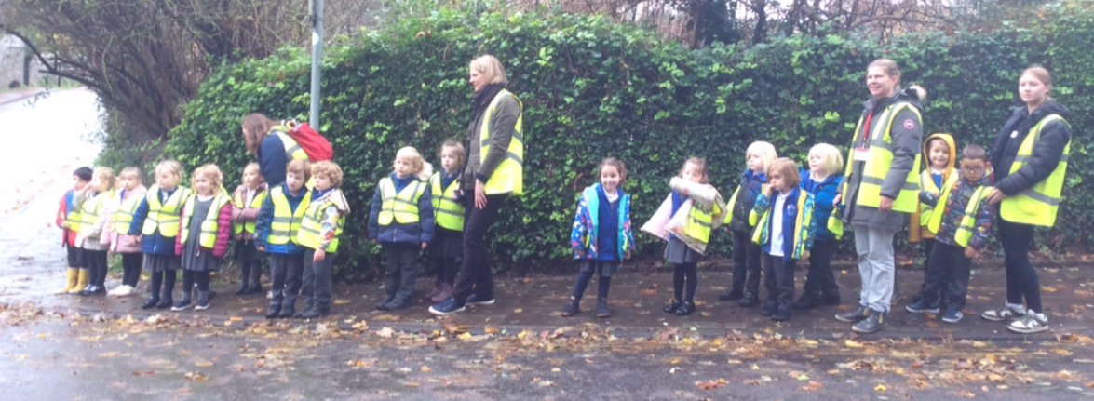
Office News
When returning a slip for a trip/ consent for a sporting game/ holiday/ medical absence etc they can be popped in the box on the wall beside the office windows. This will save time waiting when there's a queue. We empty the box every day, so things won't get missed. This would be very helpful for you and the office staff.
If you pay for your child's school lunch at Southover can we politely remind you that all school lunches must be paid for in advance and via your online ParentPay account.
To ensure your balance is always in credit to cover lunches booked and not to allow your balance to fall into arrears you can set up an alert to keep you updated. Please use the link below to help.
https://support.parentpaygroup.com/hc/en-gb/articles/4409658040593-Payer-guidance-How-to-set-up-email-and-text-alerts
Looking Ahead… Friday 20th December – 1:15pm finish & INSET Days – Monday 6th January 2025, Tuesday 22nd April & Monday 2nd June.
Governors Update - We all work together —children, parents, staff, Trinity Church and the community.
A note from the governors
"We are delighted to officially welcome Helen Parkyns as our Foundation Governor, following her appointment by the diocese. The governors have been hard at work with recent Full Governing Body, Finance, and school visits meetings. This alongside training sessions, two school self-evaluation meetings, and a Diversity Group meeting. Governors also participated in the Lewes Co-operative Learning Partnership, further enhancing our collective knowledge and engagement with the wider community. A huge congratulations to all the children and staff for their outstanding Christmas performances! They have truly been a festive treat. A heartfelt thank you to the Friends for organizing an excellent and very busy Christmas Fair. Your hard work made it a fantastic event for everyone! As 2024 comes to a close, we extend our gratitude to all our children, staff, and the entire school community for a successful start to the school year. There are exciting terms ahead before we finish the school year in 2025!"
Best wishes
Burt Browne (Vice Chair)
Community News - We all work together —children, parents, staff, Trinity Church and the community.

A special mention to Lewes Garden Centre in Kingston for donating the magnificent tree in the school entrance. If you know a family who would like a 6ft tree on Friday 20th December then please let me know and it can be collected in the afternoon.


Keeping our children safe - a safe environment that meets the needs of all children.
https://www.nspcc.org.uk/keeping-children-safe/support-for-parents/
We are continuously working to ensure the safety of our children. Please speak to the Designated Safeguarding Lead (DSL) – Noel Fadden - if you have questions or concerns.
Online Safety
From talking to the children, I know that one of the ways they access YouTube is through an Xbox or PlayStation. They can stumble upon YouTube shorts and content that you would not watch with them. Have you blocked access?
You may be aware of growing support for the recent campaign to delay giving smartphones to children. This has been in the news since Feb 2024 but particularly this term when the Safer Phones Bill was introduced in the House of Commons by Labour MP Josh MacAlister on Wednesday 17th October, meaning that the government will debate how to tackle addictive phone use by children. You can read more about the Smartphone free campaign here: https://smartphonefreechildhood.co.uk/about
Visitors to the school cannot use mobile phones in the building (this includes outside the office) unless guided by staff to a suitable space. If you are entering the school building you must sign in at the office and receive a lanyard. This means you cannot take your child into class if late – please bring them to the office.
These are all part of our safeguarding procedures.
Yours sincerely,

Noel Fadden

NSPCC Website and Support
You may be interested in the support that the NSPCC can offer through their website at http://www.nspcc.org.uk/ In the section on ‘Keeping Children safe’ they provide a range of information, advice, and child-friendly animations and activities covering areas such as e-safety, anti-bullying, social networking, safe relationships, advice on talking about difficult topics…and much more! They also run a helpline for parents for help and advice, as well as for reporting concerns about children.

Compliments, Comments, Concerns and Complaints! Have you got something positive you would like to say about the school, or a comment you would like to make? Have you got something which is concerning you or an issue need to complain about? If so, please let us know in person, by letter, by phoning the school office or by email. We have set up an email specifically for this which will be monitored only by the head and the Co-Chairs of Governors: cccc@southover.e-sussex.sch.uk





