Southover CE Primary School
Everyone at Southover
achieves their potential,
is valued for who they are
and knows they belong

Telephone (01273) 473015
Headteacher: Noel Fadden
Live, Love, Learn!
www.southoverceprimary.co.uk
Email: office@southover.e-sussex.sch.uk
At Southover Church of England Primary school:
We all work together —children, parents, staff, Trinity Church and the community.
We inspire each other to learn through a vibrant curriculum, set within a safe environment that meets the needs of all children.
We gain strength from the love of God and our love for one another; we feel we belong to Trinity Church.
We value: Trust, Compassion, Friendship, Hope, Thankfulness and Fellowship.
We have a healthy mind, body and spirit to allow us to ‘Live, Love, Learn’.

Newsletter March 2025

Dear Parents, Carers and the Community of Southover,

Spring is here and sometimes we can even see it! We have been delighted to be on the field at lunchtimes on some days while other days still feel wintry and coats are needed. This term we have been talking about our school value, Compassion and we have explored this in assemblies thinking about Ramadan, Holi and Lent. We have also celebrated Neuro-Diversity Week with some children identifying traits in themselves and all learning inclusivity.
As the end of term approaches, we welcome back Ms Hannah Bryant from her maternity leave and say thank you to Ms Lily Edmonds who has been teaching in Nightingale class on a Friday. She has fitted in with the staff team so well over the last six months.
We were pleased to be able to have a visit from James MacCleary, our local MP. He spoke to the school in an assembly about his role and then met with the School Council for questions. We found out he works a lot of hours and that he works with MPs from all parties in committees. One great question asked of him was why are they called ‘parties’ if there is no cake involved?

Continuously Developing the School – part of our School Development Plan We have a healthy mind, body and spirit to allow us to ‘Live, Love, Learn’.

Our Diversity group met on Tuesday 25th February to share ideas to improve what we offer in terms of increasing awareness of diversity and ensuring everyone feels valued and knows they belong. We have been working to increase diversity and awareness including:
- more diversity themes in assemblies
- modern reading texts telling stories that reflect the diverse society we live in
- a more representative outlook on British society in our curriculum coverage
- working on being an Anti-Racist school and increasing staff training to be able to support our community to ensure ‘Everyone is valued for who they are and knows they belong’.
If you feel you can add to our ideas then please join in our next meeting on Tuesday 29th April 3:30-4.15pm (with children welcome to sit and read in the library with us).

Miss Miller has coordinated and promoted a competition for those children lucky enough to speak more than one language. We have some gorgeous pieces of writing from children presented in two languages including: Ukrainian, Arabic, Chinese, French and Croatian. They are in English and another language so we can all understand and will be on the school website to celebrate the children’s skills and diversity.

Library Pre-School Session – An opportunity for pre-schoolers to use the lovely library and build familiarity with school. Please come along at 9.00-9.30am Friday 4th April and you are welcome to bring a friend.
Enrichment - We inspire each other to learn through a vibrant curriculum
World Book Day was a great success with teachers and children looking fantastic on the day and a high level of interest in quality texts being seen. Ms Hayward-Tapp (our English lead and reading maestro) organised competitions and events for the children and was delighted with the engagement and interest in reading.

Music

We were delighted to have a top local violinist in assembly this week to play for the children as they learnt about the upcoming Lewes Passion play and Johann Sebastian Bach.
Music lessons are flourishing at Southover and our music room is busy every day.
Monday-Violin
Tuesday-Cello, Flute and woodwind
Wednesday-Drumming
Thursday-Guitar
Friday-Piano
To join these contact createmusic

Sport We have a healthy mind, body and spirit
We have been delighted to welcome coaches from Sussex CCC who have been working with Y3/4 classes this term as part of a Sussex CCC schools programme. They have also been running an after-school club for children Y4 to Y6 and Play Leaders training at lunchtimes. Cricket Club will start next term on Mondays for girls and boys Y4 to Y6. We will have cricket teams playing matches later in the year.

Football

The Lewes football league finished last week and 26 players represented the school. They played under the floodlights at Southdown club and I could see their skills improving in each match they played.
At the end, one team finished equal top of their league but lost out on being champions on goal difference to Wallands School. The other teams finished 5th and 6th in their groups with Ringmer being the top team in the other league.
Our players were: Lenny, Ronnie, Bertie, Jacob, Spencer, Alfie, Amelia, Brooklyn, Layla, Dylan, Vincent, Mila, Flo, Joseph, Locryn, Leo, Logan, Cassius, Robin, Edwin, Nico, George, Gabriel, Louie and Buster

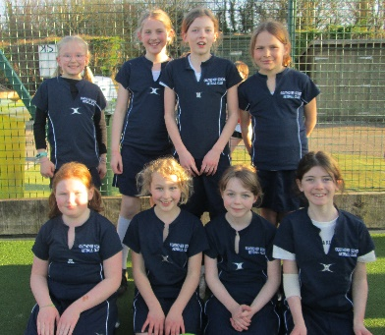
Netball
A team of netballers played in a Lewes festival this term and in the Lewes competition at the Southdown Club. They were playing their first games for the school and learnt so much. Thank you to Miss Miller for running training each Friday morning and taking the children to the festival. They improved as each game went by. The team in the competition was made up of children from Y3 to Y5 taking the opportunity to prepare for future years as they competed with Y5 and Y6s.

Chess
The annual Southover Chess tournament run as part of a national chess competition came to an end last week. Thirty-two children competed over seven weeks and gained badges and mascots as their points totted up. They showed superb commitment and manners and definitely tested their brains and nerves. Some of the highest scorers will be invited to try the regional round of the national tournament and the top three have taken away trophies to treasure.

The top ten were:
Place | Name | Year | Points
1 | Joseph B | 5 | 20
2 | Yaser | 4 | 19
3 | Holly | 6 | 18
4 | Joseph W | 4 | 17
4 | Bertie | 6 | 17
4 | Lana | 5 | 17
7 | Louie | 5 | 16
7 | George | 5 | 16
7 | Spencer | 6 | 16
10 | Molly | 6 | 15
10 | Bea | 4 | 15
10 | Dylan | 5 | 15
10 | Gabriel | 5 | 15

Lunchtime Clubs

We are delighted to have a Coding Club running on Wednesday lunchtimes helping create future tech wizards. Would anyone be able to offer an hour a week at lunchtime to run a club? We would love to offer an extra chess club, a library session or a table tennis club. Please let me know.
Curriculum Updates - We inspire each other to learn through a vibrant curriculum
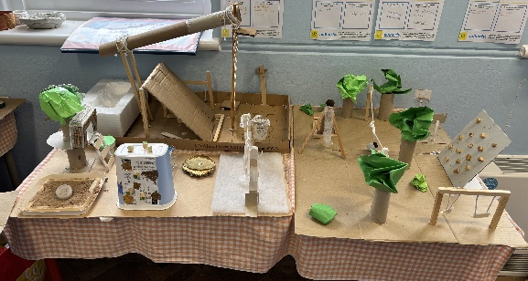
This Spring term has been very busy for Year 5 and 6: the children loved dressing up on World Book Day; they enjoyed a webcast with Michael Rosen and had great fun guessing who was who in our Masked Reader. They have impressed parents and teachers alike with their creative Aspirational People projects, which they talked about confidently to the many visitors who came on exhibition day. In Science, they have enjoyed investigating how light travels and even made their own periscopes. Meanwhile, in Geography they have learned about the Amazon Basin and made enjoyed making informative posters about the importance of the Amazon River. Programming a Microbit to function as a counter and record repetitive exercises has been great fun and in PE we have been working on our teamwork and jumping skills. Both Eagle and Falcon have been working hard in DT, designing and building their playgrounds; Nightingale have mastered two songs on the ukulele with tricky strumming patterns and have been exploring the theme of identity in Art lessons through collage and sketching.
In Year 5, we have loved being journalists and writing newspaper articles based on a fairytale crime. Currently, we are using the picture book 'The Barnabus Project' to write adventure stories: the children have invented their own 'failed project' characters that will need to be rescued by Barnabus and the gang! In Maths, we have been busy working with decimals and we were impressed by the children's super resilience during their assessments. Both classes are thoroughly enjoying reading Crookhaven and have especially liked taking part in some Authorfy creative writing challenges this term.
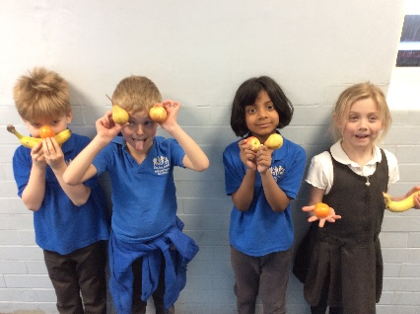
In Year 6, the children greatly enjoyed writing complaint letters and made some excellent vocabulary choices to show how disappointed they were! Currently, we are preparing to write newspaper articles linked to saving the Amazon and have been working on our journalistic writing skills.
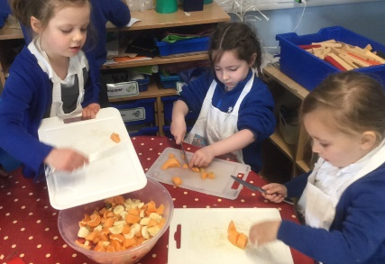
KS1 have had a busy term learning about the continents and oceans in geography. There may have taught you a song relating to the seven continents. In DT, the children have been busy developing their cutting and juicing skills in order to design and make a smoothie. We are patiently waiting for our caterpillars, which are getting bigger and bigger, to emerge as beautiful butterflies. What a lovely sign of Spring!
Heron have been growing plants and talking about their use in our growing topic. We have been practising safely using knifes and designing our own fruit salad. We also had a trip out to Lewes library; don’t forget to visit too.
Governors’ News
As governors, guided by our experienced Clerk Denise Kong, our role is to support and challenge the school in ways that benefit staff and pupils. Over the past few weeks, we have worked closely with the Senior Leadership Team and other stakeholders to support the school’s work. At School Evaluation Form (SEF) meetings, we have worked with the leadership team to assess strengths and areas for development, helping to shape future priorities. With the expertise of our School Business Manager, Jo Roadway, we have helped to review and guide budget decisions through our Finance and Full Governing Board meetings, ensuring financial resources are allocated effectively to support our children’s learning and wellbeing.
A huge thank you to Governor Michele Moore, who arranged the MP visit. He explained his role and responsibilities and took part in a short Q&A session with pupils (and yes, the potholes problems were noted!).
We build knowledge through our involvement with the Lewes Co-operative Learning Partnership (LCLP) where we continue to share best practices with other local schools and explore opportunities for collaboration. We also attend training (Governors have to go to school too) and networking meetings so we are developing our expertise to provide effective governance and oversight.
Thank you for your continued support, and we wish everyone a restful and enjoyable Easter break.
Burt Browne (Vice-Chair)
Office News
When returning a slip for a trip/ consent for a sporting game/ holiday/ medical absence etc. they can be popped in the box on the wall beside the office windows.
If you pay for your child's school lunch at Southover, can we politely remind you that all school lunches must be paid for in advance and via your online ParentPay account. To ensure your balance is always in credit to cover lunches booked and not to allow your balance to fall into arrears you can set up an alert to keep you updated. Please use the link below to help.
https://support.parentpaygroup.com/hc/en-gb/articles/4409658040593-Payer-guidance-How-to-set-up-email-and-text-alerts
Looking Ahead…
INSET Days –Tuesday 22nd April & Monday 2nd June.
Sports Day - Wednesday 9th July
Tuesday 22nd July – Last day of the year 1.15pm finish

Community News - We all work together —children, parents, staff, Trinity Church and the community.


Keeping our children safe - a safe environment that meets the needs of all children.
https://www.nspcc.org.uk/keeping-children-safe/support-for-parents/
Online Safety
We know how easy it is to give a phone to a child to keep them entertained while waiting somewhere but we have all had to spend time waiting and after a few minutes our creative minds and imagination take over. The value of conversation with children of all ages cannot be underestimated from 0 to 19 and beyond! As teachers we can see the language development in children who have lots of talking opportunities from the day they are born.
Smoothwall is our school filtering and monitoring service. It filters out potentially harmful content and flags up searches for the Safeguarding Lead to check. Acceptable Use Agreements are in place at school so all children know how to use the technology safely.
We are continuously working to ensure the safety of our children. Please speak to the Designated Safeguarding Lead (DSL) – Noel Fadden - if you have questions or concerns.

Visitors to the school cannot use mobile phones in the building (this includes outside the office) unless guided by staff to a suitable space. If you are entering the school building you must sign in at the office and receive a lanyard. This means you cannot take your child into class if late – please bring them to the office.
These are all part of our safeguarding procedures.
Yours sincerely,

Noel Fadden

NSPCC Website and Support
You may be interested in the support that the NSPCC can offer through their website at http://www.nspcc.org.uk/ In the section on ‘Keeping Children safe’ they provide a range of information, advice, and child-friendly animations and activities covering areas such as e-safety, anti-bullying, social networking, safe relationships, advice on talking about difficult topics…and much more! They also run a helpline for parents for help and advice, as well as for reporting concerns about children.

Compliments, Comments, Concerns and Complaints! Have you got something positive you would like to say about the school, or a comment you would like to make? Have you got something which is concerning you or an issue need to complain about? If so, please let us know in person, by letter, by phoning the school office or by email. We have set up an email specifically for this which will be monitored only by the head and the Co-Chairs of Governors: cccc@southover.e-sussex.sch.uk





